Your Daily Bladder Diary

This diary will help you and your health care team figure out the causes of your bladder control trouble. Please keep the diary for 3 days. The “sample” line shows you how to use the diary.
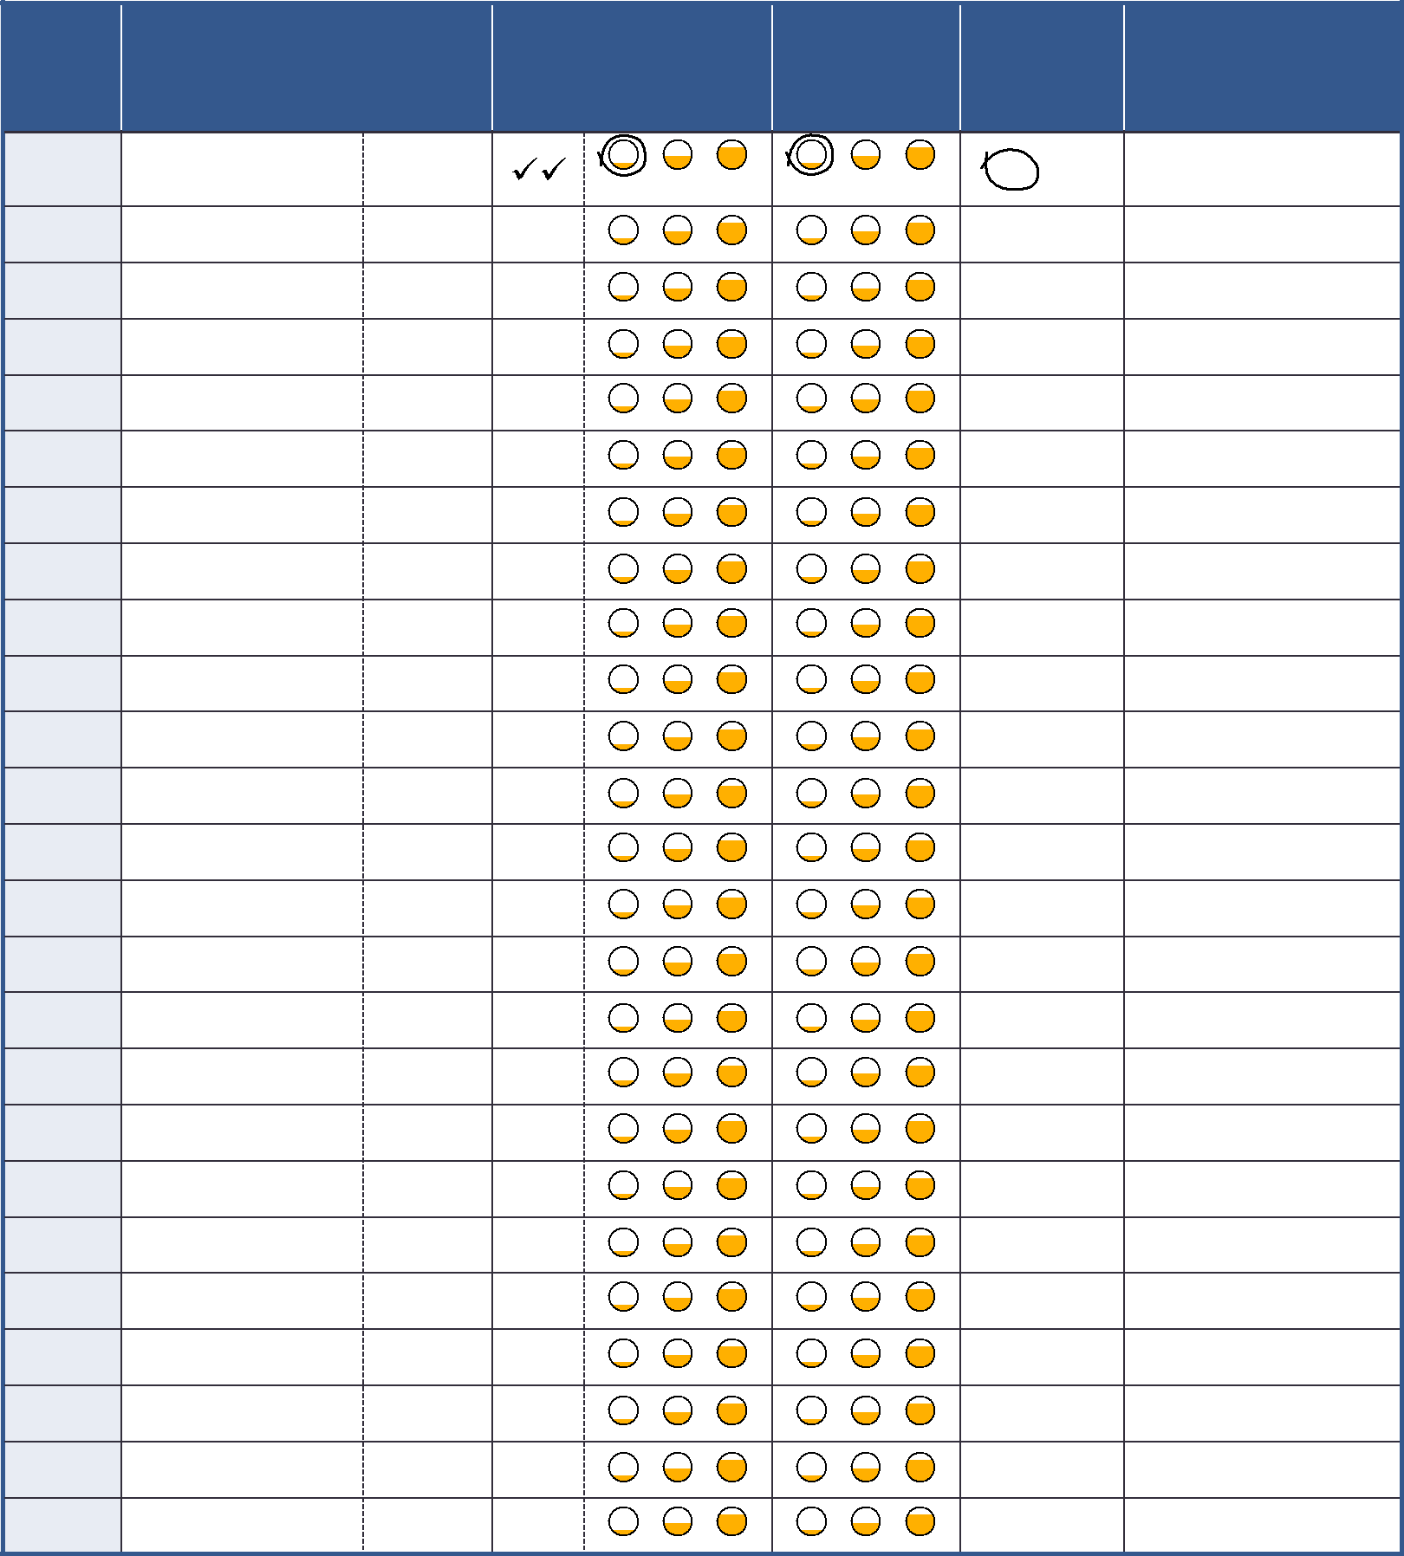

Time | Drinks |  | Trips to the Bathroom |  | Accidental | Did you feel |  | What were you doing
 |  |  |  |  | Leaks | a strong urge |  | at the time?
 | What kind? | How much? | How many | How much | How much urine? | to go? |  | Sneezing, lifting, arriving home,
 |  | oz, mL, cups | times? | urine? |  |  |  | sleeping, etc.
Sample | Juice | 8 ounces | sm | med lg | sm med lg | Yes | No | Running
6 – 7 a.m. |  |  |  |  |  | Yes | No
7 – 8 a.m. |  |  |  |  |  | Yes | No
8 – 9 a.m. |  |  |  |  |  | Yes | No
9 – 10 a.m. |  |  |  |  |  | Yes | No
10 – 11 a.m. |  |  |  |  |  | Yes | No
11 – 12 noon |  |  |  |  |  | Yes | No
12 – 1 p.m. |  |  |  |  |  | Yes | No
1 – 2 p.m. |  |  |  |  |  | Yes | No
2 – 3 p.m. |  |  |  |  |  | Yes | No
3 – 4 p.m. |  |  |  |  |  | Yes | No
4 – 5 p.m. |  |  |  |  |  | Yes | No
5 – 6 p.m. |  |  |  |  |  | Yes | No
6 – 7 p.m. |  |  |  |  |  | Yes | No
7 – 8 p.m. |  |  |  |  |  | Yes | No
8 – 9 p.m. |  |  |  |  |  | Yes | No
9 – 10 p.m. |  |  |  |  |  | Yes | No
10 – 11 p.m. |  |  |  |  |  | Yes | No
11 – 12 mid. |  |  |  |  |  | Yes | No
12 – 1 a.m. |  |  |  |  |  | Yes | No
1 – 2 a.m. |  |  |  |  |  | Yes | No
2 – 3 a.m. |  |  |  |  |  | Yes | No
3 – 4 a.m. |  |  |  |  |  | Yes | No
4 – 5 a.m. |  |  |  |  |  | Yes | No
5 – 6 a.m. |  |  |  |  |  | Yes | No

I used pads today. I used adult incontinence products today.

Questions to ask health care provider:

